Ski Mountaineering School
Student Application for Admission

Colorado Mountain Club - Denver Group

Name ___________________________________________ Age ______ Male ___ Female ___

Address _____________________________________ City _________________ Zip _______

Telephone: Home ____________________________ Work ____________________________

Preferred Email Address ________________________________________________________

CMC Membership Group __________________________ Member Since (Year) ___________

Year Completed AIARE level 1 Avalanche School: __________ Provider (CMC, AAI, or other): ____________
Indicate the Level of the Avalanche School Completed: _________________________________

Year Completed First Aid Course: ___________ Provider (Red Cross, CMC, or other): ______________________________________________________________________________

Year Completed BMS _________________________
Completion of the Basic Mountaineering School (BMS) is recommended but not required for the school.

Current CMC Skiing Classification (for Denver Group members only):
Moderate: _____ Year Granted: _________
Advanced: _____ Year Granted: _________

Please answer the following questions as completely as possible.

1. How many CMC skiing and climbing trips did you complete in the last two years?
“Moderate” Ski Trip Classification =  “Advanced” Ski Trip Classification = | C Trip Hike or Climb Classification =  D Trip Hike or Climb Classification =
2. How many CMC trips did you lead as a trip leader or leader in training in the last two years?
“Moderate” Ski Trip Classification =  “Advanced” Ski Trip Classification = | C Trip Hike or Climb Classification =  D Trip Hike or Climb Classification =
3. What CMC schools, seminars, or other training have you completed? Year
4. List training outside of CMC such as first aid, mountaineering, rock climbing, skiing, or avalanche schools. Year
5. List volunteer CMC activities where you helped or led/taught (for example teaching in CMC schools, serving as CMC officer, serving on CMC committees, trail maintenance, office support.)

6. How would you rate your skiing ability? On which type of skiing terrain are you now comfortable?
Downhill Resort Skiing Difficulty – Choose the most difficult level at which you would be comfortable skiing under normal circumstances.
(a) Green Ski Runs ________________
(b) Blue Ski Runs _________________
(c) Single Black Diamond Runs ______
(d) Double Black Diamond Runs _____

Backcountry Skiing Difficulty – Choose the most difficult level at which you would be comfortable skiing under conditions under the avalanche risk indicated (although you would judge the avalanche risk at the time to be acceptable):
- Slopes up to 25 degrees. Easy terrain/broad slopes/good snow. Sideslip and stem turn.
will get you down. Avalanches unlikely. ______________________________________
- Longer pitches up to 25 degrees. Can be steep narrow trail or slope descent. Avalanches
unlikely. ________________________________________________________________
- Angle at or near 25 degrees. Rougher terrain and/or more difficult snow. Able to link
several turns. Avalanches possible at times. ____________________________________
- Slopes up to 30 degrees. Similar to an easy expert run at resort. Avalanche possible at
times. ___________________________________________________________________
- Slopes up to 35 degrees. Similar to expert run at resorts. Prime avalanche terrain under
certain conditions. _________________________________________________________
- Slopes up to 35 degrees with difficult terrain features and more difficult snow. Prime avalanche terrain under certain conditions. _______________________________________
- Slopes over 35 degrees but under 45 degrees without terrain obstacles and with reasonably safe runouts. Prime avalanche terrain under certain conditions. _______________________
- Slopes over 35 degrees but under 45 degrees. May have fall potential and terrain obstacles such as narrows. Prime avalanche terrain under certain conditions. ___________________
- Slopes of 45 degrees or over. May have fall potential and terrain obstacles. Because snow can’t easily accumulate at these angles, slab avalanches are less common but can occur. Loose snow avalanches are common under most conditions. Bona fide extreme skiing. ______________________

Backcountry ski travel experience
Do you own/have used backcountry skis w/ touring bindings, skins and boots? If yes, how many days/ season have you used them and for how many seasons?

Do you own/have used ski crampons? If yes, how many days/ season have you used them and for how many seasons?

Have you “booted” or climbed and used an ice axe with skis on your pack to access ski routes?

Have you used exit gates at ski areas to ski “of piste”?

Have you ski toured/ “earn your turns”? If yes, how many days/ season have you ski toured, and for how many seasons?

Have you spring skied on peaks? If yes, how many days/ season have you peak skied, and for how many seasons?

What is your typical pace when backcountry skiing in miles / hr and vertical climb ft/ hr? and what is a “good long” ski tour day for you in hours/ distance/ vert?

Other indications of your skiing ability, such as examples of recent ski tours:

7. Basic ice axe snow skills are expected for participants of the school. Have you done any snow or ice climbing with an ice axe and crampons in the last year? If so, include names of routes, ratings or difficulty, and other descriptions of the climbs.
8. What ski touring, mountaineering, backpacking, camping, or hiking trips have you completed during the past year? Include names of peaks, CMC trip ratings, trips outside of CMC, number of days, level of difficulty, or other indications of your level of mountaineering skills and stamina.
9. Why do you want to enroll in the Alpine Touring/Ski Mountaineering School, and what do you expect to learn/experience?
What will you do with the skills, knowledge, and experience?
How will the skills and experience gained from the school fit with your skiing, mountaineering, and climbing goals?

10. For your safety and the safety of your group, please list any medical conditions which might affect your participation in the school or medical characteristics your instructors need to understand. If you have medical training beyond a first aid course, please indicate.
Medical Conditions, if any:

Medical Training (Beyond First Aid):

In Case of Emergency, Notify:

Name: ________________________________________________________________________

Telephone Number(s): ___________________________________________________________

Relationship: ___________________________________________________________________

Address: ______________________________________________________________________

City: ________________________ State: ________________ Zip Code: ___________________

Signature

Printed Name

Date of Application

I plan to use the following gear:

Randonee or AT skis _____

Telemark skis _____

Split Snowboard _____

Requests for waivers of prerequisite requirements should be made in writing at the time of the application.

Please e-mail or mail completed application (without payment) to:

John Morrone
E-mail: jmorrone57@gmail.com

Ski Mountaineering School  Student Registration  Colorado Mountain Club | 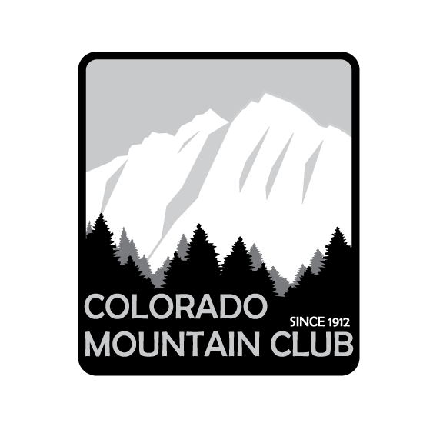

Complete this form after you have been accepted to the School.

Member Information Date:
Name | Memb. # | Home Phone
Address | Group | Work Phone
City, State | Zip Code | e-mail

Payment Options
Tuition: $100.00 | Check # | MasterCard VISA American Express Discover
Card # |  |  |  | Expiration:
Name on the card: |  |  | Signature:

CMC Denver Group Standard Refund Policy

REFUND POLICY: Requests must be made in writing to school director. If received at least 31 days before a course begins, Full refund less $35/person processing, less cost of materials received, if any. If between 8 to 30 days, Full refund less 25% of fee paid but no less than $35/person processing fee. If less than 7 days, No refund or credit. See https://www.cmc.org/cancel.

Email this form jmorrone57@gmail.com

